1. 1Topology

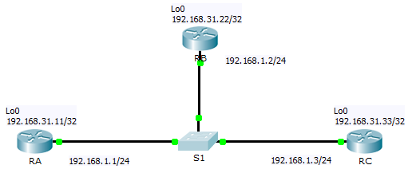

1. Addressing Table

|  |  |  |  |
| --- | --- | --- | --- |
| Device | Interface | IP Address | Subnet Mask |
| RA | G0/0 | 192.168.1.1 | 255.255.255.0 |
| Lo0 | 192.168.31.11 | 255.255.255.255 |
| RB | G0/0 | 192.168.1.2 | 255.255.255.0 |
| Lo0 | 192.168.31.22 | 255.255.255.255 |
| RC | G0/0 | 192.168.1.3 | 255.255.255.0 |
| Lo0 | 192.168.31.33 | 255.255.255.255 |

1. Configure OSPF routing with area 0 (router ID set to default - Do not set router ID) on each router RA, RB and RC.
2. Examine DR and BDR Changing Roles
   1. Verify the router ID of the routers: ______________

* 1. Verify the current OSPF neighbor states.
     1. Use the appropriate command on each router to examine the current DR and BDR (show ip ospf neighbor) .
     2. Which router is the DR? ________( Desiguate Router )
     3. Which router is the BDR? _______( Backup DR )

Còn lại Dr other

* 1. Disable the Gigabit Ethernet 0/0 interface on RC.
     1. Disable the link between **RC** and the switch to cause roles to change.
     2. Wait about 30 seconds for the dead timers to expire on **RA** and **RB**. According to the debug output, which router was elected DR and which router was elected BDR?

____________________________________________________________________________________

* 1. Restore the Gigabit Ethernet 0/0 interface on RC.
     1. Re-enable the link between **RC** and the switch.
     2. Wait for the new DR/BDR elections to occur. Did DR and BDR roles change? Why or why not?

____________________________________________________________________________________

____________________________________________________________________________________

* 1. Disable the Gigabit Ethernet 0/0 interface on RB.
     1. Disable the link between **RB** and the switch to cause roles to change.
     2. Wait about 30 seconds for the holddown timers to expire on **RA** and **RC**. According to the debug output on **RA**, which router was elected DR and which router was elected BDR?

____________________________________________________________________________________

* 1. Restore the Gigabit Ethernet 0/0 interface on RB.
     1. Re-enable the link between **RB** and the switch.
     2. Wait for the new DR/BDR elections to occur. Did DR and BDR roles change? Why or why not?

____________________________________________________________________________________

____________________________________________________________________________________

1. Modify OSPF Priority and Force Elections
   1. Configure Router ID on each router.

* **RA**: 2.2.2.2
* **RB**: 3.3.3.3
* **RC**: 1.1.1.1
* Set OSPF priority is 1 on interface g0/0 each router.
  1. Run comand clear ip ospf process on any router to reset the OSPF process.

Verify the current OSPF neighbor states: Which router is the DR? ______________; Which router is the BDR? ______________

* 1. Configure OSPF priorities on each router.

To change the DR and BDR, configure the Gigabit Ethernet 0/0 port of each router with the following OSPF interface priorities:

* **RA**: 200
* **RB**: 100
* **RC**: 1 (This is the default priority)
  1. Force an election by reloading the switch.

**Note:** The command **clear ip ospf process** can also be used on the routers to reset the OSPF process.

* 1. Verify DR and BDR elections were successful.
     1. Wait long enough for OSPF to converge and for the DR/BDR election to occur. This should take a few minutes. You can click **Fast Forward Time** to speed up the process.
     2. According to output from an appropriate command, which router is now DR and which router is now BDR?

1. Expand the diagram as shown (remember to save the configuration at RC before expanding)

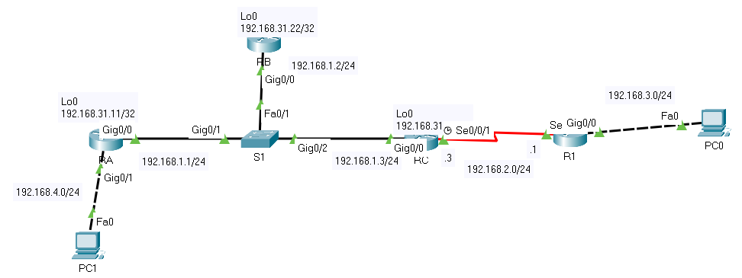

* 1. Set up ip address

PC1, G0/1 (RA), S0/0/1 (RC), s0/0/1 and G0/0 (R1), PC0

* 1. Configure additional OSPF routing for a smooth network system (using single area 0)

RA, RC, R1

* 1. Determine the cost from PC1 to PC0

Sử dụng công thức tính cost = tổng chi phí đi từ PC1 tới PC0 sử dụng công thức (metric = cost = **reference bandwidth (10^8) / interface bandwidth (bps)**)

1. Configure Multiarea OSPF routing as shown:

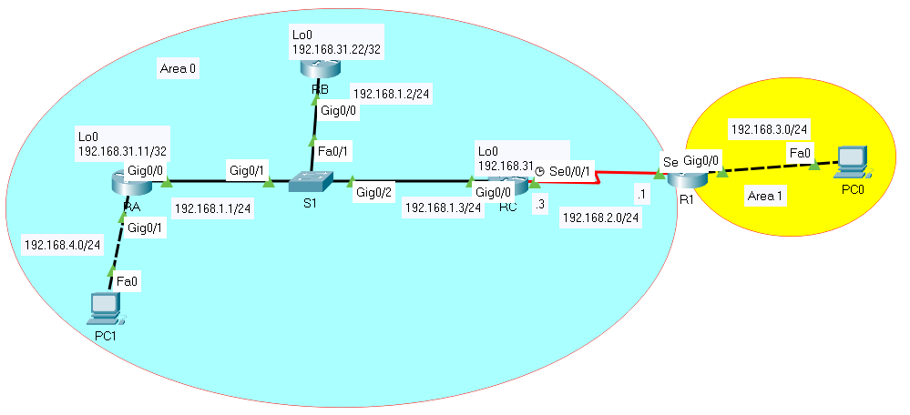

**Commands to verify multiarea OSPFv2**

* + **show ip ospf neighbor**
  + **show ip ospf interface**
  + **show ip route ospf**

Check network connectivity